**Question1:** Understand and Create VPC

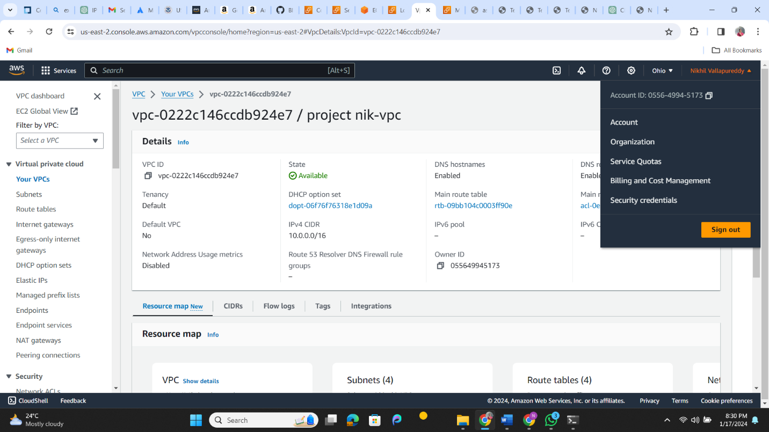

**Question 2:** Agile vs DevOps

Agile emphasizes collaboration between developers and product management -----DevOps includes the operation team

Agile centers the flow of software from ideation to code completion – DevOps extends the focus to delivery.

**Question 3:** DevOps KPIs

**Ans:**

1. Deployment Frequency
2. Change Volume
3. Deployment time
4. Failed Deployment rate
5. Change failure rate
6. Time to detection
7. Meantime to Recovery
8. Lead time
9. Defect Escape rate
10. Defect Volume
11. Availability
12. Service Level Agreement Compliance
13. Unplanned work
14. Customer Ticket volume
15. Cycle time